Increment Borer

A specialized tool which enables a core sample to be extracted from a tree trunk or branch.

The borer consists of three parts which are all stored conveniently inside the handle. The parts are

* A = The Handle. A metal tube with square slot and clip to allow fixing of the Auger.
* B = The Auger. A hardened steel tube with a cutting tip at one end and a square section at the other.
* C = The Extractor. A thin steel half-moon blade. 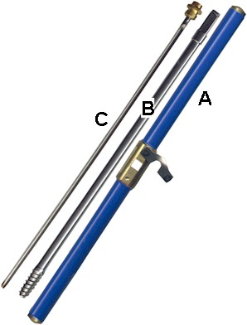

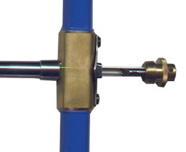To use, first insert the square end of the Auger into the Handle and secure with the swing-clip. The Auger is now screwed into the tree to the depth required. The Extractor is next inserted into the Auger and held firmly in place while the whole Auger is turned a quarter turn anti-clockwise to break the sample. The extractor is now removed from the Auger complete with the wood sample. The Auger is then unscrewed from the tree.

Increment Borers are available in a number of different sizes to allow penetration of different depths. The above photographs illustrate the **Mattson Increment Borer (12"/300mm)**.